<http://jira.pentaho.com/browse/DOC-3067>

DOC - Visual Exploration Experience needs browser support clarification (maybe other places too?)

Inspecting Your Data

https://help.pentaho.com/Documentation/7.0/0L0/0Y0/030/Inspecting\_Your\_Data

When working with your transformation, you can gain valuable insights by visualizing and interacting with your data in many ways. The ability to quickly inspect step data reduces the amount of iterative work needed while building your transformation and enables you to rapidly publish a data source to share with either your teams or across your organization.

*Note: Depending on your operating system, you may need to upgrade your Web browser for the full experience. See our list of supported components [here](#_Web_Browsers).*

Begin Inspecting

Begin inspecting your transformation by clicking on a step. This displays the **fly-out inspection bar** at the top of the canvas area. The bar displays the name of the step selected and offers two options:

* **Inspect Data**- Lets you inspect the data of a step once the transformation has run.  
  *Note: This option is not available until you run your transformation.*
* **Run and Inspect Data**- Runs the transformation, then lets you inspect the data of a step.

Additionally, you can begin inspecting in the following ways:

* **Step Context Menu** - Right-click on a step and choose either **Inspect Data** or **Run and Inspect Data**.
* **Preview Data Panel**- Select the **Preview Data** tab. Click the **Inspect Data** button located at the top right of the **Preview Data** bar.
* **Actions Menu**- Select a step. From the **Menu**bar, click **Action**>**Inspect Data** or **Action**>**Run and Inspect Data**.
* **Keyboard Shortcuts -**Select a step. Then using your keyboard:
  + In Windows**,** press either **Shift+Ctrl+F9**(Inspect Data) or **Ctrl+F9**(Run and Inspect Data).
  + In OS X, press **Shift+Command+F9**(Inspect Data) or **Command+F9**(Run and Inspect Data).

Tour the Environment

When you decide to inspect your data, the transformation presents options to visualize your data.

By default, table data is displayed with all available fields selected in **Stream View**.

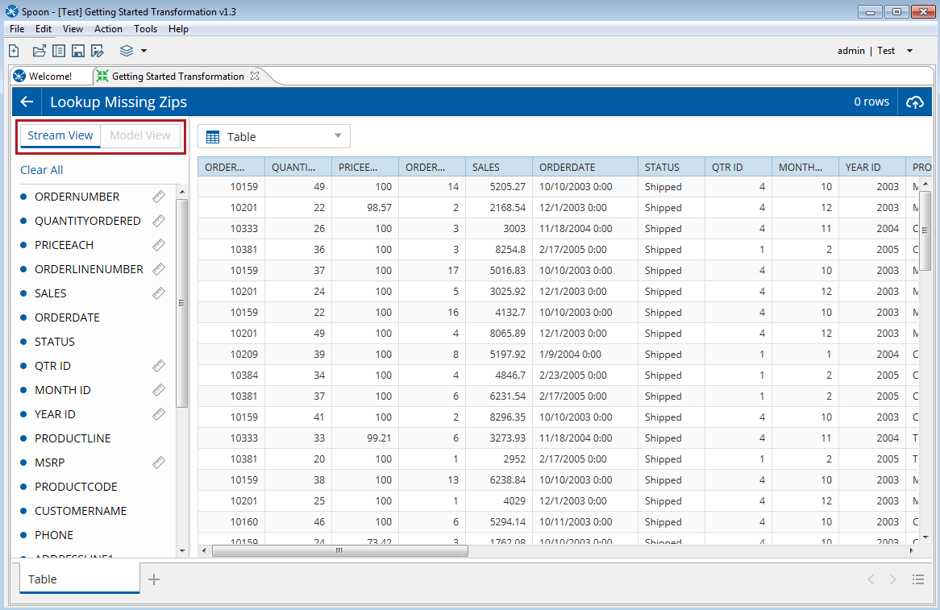

The following sample screen shows a visualization using data field values from the default Stream View for a step.

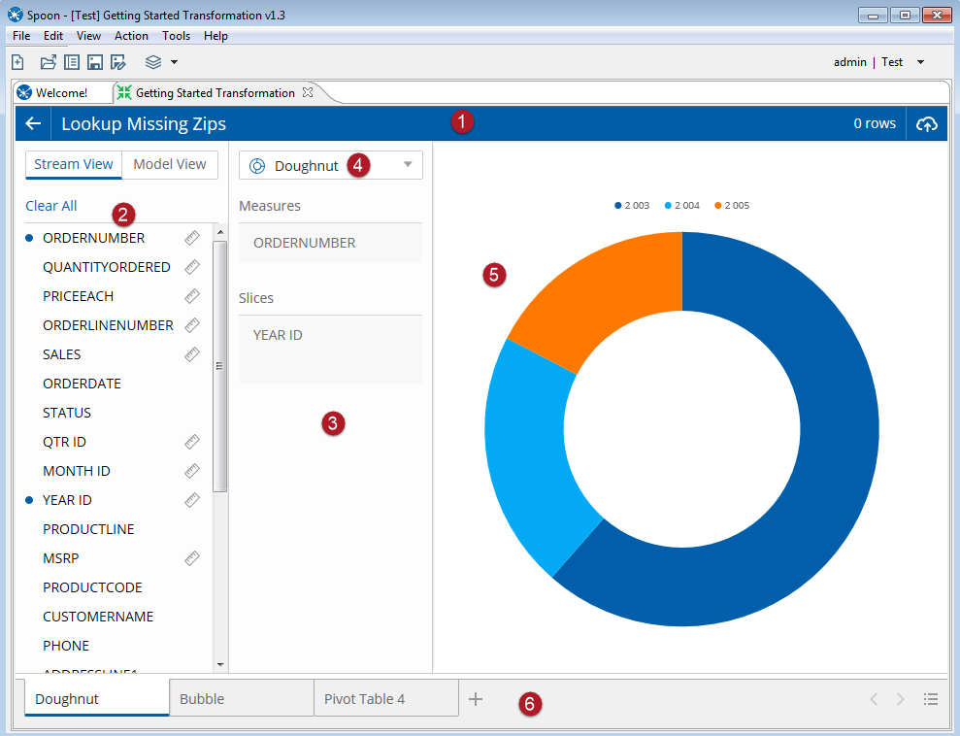

Use the number locators in the sample screen to reference the sections of the inspection environment.

| Key | Name | Description |
| --- | --- | --- |
| Circle 1 | **Header bar** | Use the Header bar to access:   * The title of the step being inspected. * The row count of the data sampled. * The **Publish**button, used to create a data source for collaborative use later via a data service. * The **Exit**button, to return to the transformation canvas |
| Circle 2 | **Available Fields Panel** | Toggle between **Stream View** and **Model View** to begin inspecting data and building visualizations based on the data sampled.   * Use **Stream View** to inspect the data sampled using a flat table or certain visualization types that don't require modeling. * **Model View** extends the analytic capabilities by allowing you to view your selected fields with multi-dimensional capabilities. * The **Available Fields Panel** lists all available data fields from the subset of data being inspected and allows you to select the specific data fields you want to inspect. Click a data field to select or deselect. In **Model View**, you can also select a field by dragging it into the **Layout Panel**. Selected fields display a blue bullet point symbol to the left of their names. * Use **Select All** in Stream View to include all data fields in Table format. * Use **Clear All** to deselect all data fields. The **Canvas**area will be automatically updated. |
| Circle 3 | **Layout Panel** | Displays the properties associated with a selected category or field. |
| Circle 4 | **Visualization Selector** | Use the **Visualization Selector** to choose a visualization type. Selecting a visualization from the drop-down menu displays it in the **Canvas**area. |
| Circle 5 | **Canvas** | The **Canvas**displays the selected visualization. |
| Circle 6 | **Visualization Tabs** | Use the **Visualization Tabs** to compare multiple views of your step data. |

Explore with Visualizations

When you begin inspecting your data, you are presented with the **Stream View**, with all available data fields selected. The selected data fields are represented in the **Canvas** area by a flat table. To reduce the number of data fields selected, click anywhere on a data field name. The blue dot to the left of the data field name will disappear, indicating that it is no longer selected. In some cases, it may be faster to deselect all data fields first, by clicking the Clear All actions first, then select only the data fields you want to inspect. Your selections will be listed in the order that they are selected.

Once you have the desired data fields selected, you can change the table to a different visualization type by using the **Visualization Selector**. Alternately, you can create a new visualization by clicking the plus symbol button located to the right of the current tab. Once you have a new visualization created, switch to **Model View** to display a multidimensional representation of your selected fields. If you selected a visualization that requires a multidimensional model, it will automatically switch to Model View. The Model View allows you to customize the layout, based on placement of the data fields shelves.

You can always return to the inspection canvas and fine tune your transformation at any time until you are satisfied with the results.

*Note: When you exit the inspection environment and return to the Data Integration canvas, all tabs will be discarded.*

One you feel that your step data is in a good place, you can make the content available for further collaboration by publishing a data source.

Publish for Collaboration

When you’re ready to make your content available for others, publish it as a data source. The data source will use a data service that is automatically created on the step, which can be used by other tools at a later time.

To publish, perform the following steps:  
1. Click the **Publish**button at the top right of the **Header**bar. The **Publish Data Source** window opens.  
2. Click **Get Started** to open the **Publish Details** window.

Enter the data source information in the following fields:

| Fields | Description |
| --- | --- |
| **Data Source Name** | The name used by other Pentaho applications when accessing your data source. |
| **Server** | The default value for this field is your current repository. You can select other repository connections if you have created them through the **Repository Manager**. |
| **URL** | The base URL string used to connect to the server. |
| **User Name** | The user name required to access the server.  The user must also have publish permissions. |
| **Password** | The password associated with the provided user name |

3. When you are done, click **Finish**.

4. Once your data source is created a confirmation will appear. Click **Close**to continue inspecting or return to **PUC** to work with the data source. The data source should now be available on the server.

Components Reference

[https://help.pentaho.com/Documentation/7.0/0D0/160/000#Web\_Browsers](https://help.pentaho.com/Documentation/7.0/0D0/160/000" \l "Web_Browsers)

## Web Browsers

Pentaho supports major versions of Web browsers that are publicly available six weeks prior to the finalization of a Pentaho release, except as noted below.

| Pentaho Software | Web Browser |
| --- | --- |
| Pentaho User Console (PUC) | * Apple Safari 9.x & 10.x *(Note: On OS X only)* * Google Chrome 53 & 54 * Microsoft Edge * Microsoft Internet Explorer 11 *(Note: Does not render PUC correctly using Compatibility Modes)* * Mozilla Firefox 48 & 49 |
| Pentaho Report Designer | * Apple Safari 9.x & 10.x *(Note: On OS X only)* * Google Chrome 53 & 54 * Microsoft Edge * Microsoft Internet Explorer 11 * Mozilla Firefox 48 & 49 |
| Pentaho Data Integration (PDI) client | * Apple Safari 9.x & 10.x *(Note: On OS X only)* * Google Chrome 53 & 54 * Microsoft Internet Explorer 11 *(Note: Required on Windows for data inspection and other features.)* * Mozilla Firefox 48 & 49 *(Note: Linux requires* ***[libwebkitgtk](#_Use_the_Pentaho)****[-1.0](#_Use_the_Pentaho).)* |

## Install PDI Tools and Plugins

## <https://help.pentaho.com/Documentation/7.0/0F0/Install_the_Pentaho_Client_Tools/Install_PDI_Tools_and_Plugins>

## Use the Pentaho Installation Wizard to Install the PDI Client, Utilities, and Plugins

The preferred method for installing the PDI client, utilities, and plugins is to use the Pentaho Business Analytics Installation Wizard.

1. Run the Pentaho Business Analytics Installation Wizard according to the instructions in the [Install Pentaho Suite documentation](https://help.pentaho.com/Documentation/7.0/0F0/0G0/030" \o "Install the Pentaho Suite Using the Installation Wizard). Be sure to perform the following steps while running the installation wizard.
2. On the Setup Type window, select the **Let me decide for myself** option.
3. When the **Pentaho Applications** window displays during the installation process, select the **Data Integration (ETL)** check box.
4. When the installation wizard is complete, start the tools using one of the following ways:
   * **Linux:**Open a **Terminal** window, then navigate to ~/pentaho/design-tools/ and launch the tool.
   * **Mac:**Navigate to the Applications/pentaho/design-tools/ and double-click the file.
   * **Windows:** Select the tool you want to start from the **Start** menu.
5. *Linux users only*: you need to install **libwebkitgtk-1.0** on your system.  You can use the commandsudo apt-get install libwebkitgtk-1.0-0 to install the library.